**Steps to execute the test script: -**

**[ Note: -** In this project, a file named “**AboutThisProject**” is there please go throughit as it contains valuable insight about this project.**]**

1. Open the postman application and import the “**SalesHandy Project.postman_collection**” file.

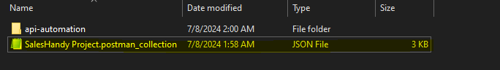

1. Once the file is imported then click on the **Collection (SalesHandy Project)**.

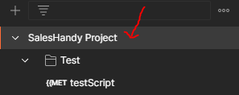

1. Then click on **Run**.

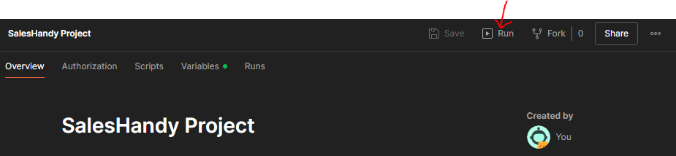

1. Once the **runner tab** is opened then upload the **endpoints/**.json** file (which will be available under **api-automation >> endpoints >> .json Files**) by clicking the **Select File**.

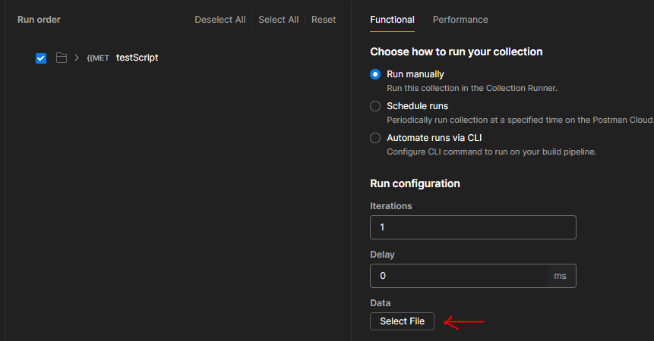

1. Once the file is uploaded then click on **Persist responses for a session** (if we want to see the response being displayed in the result page) and then click on **Run SalesHandy Project**.

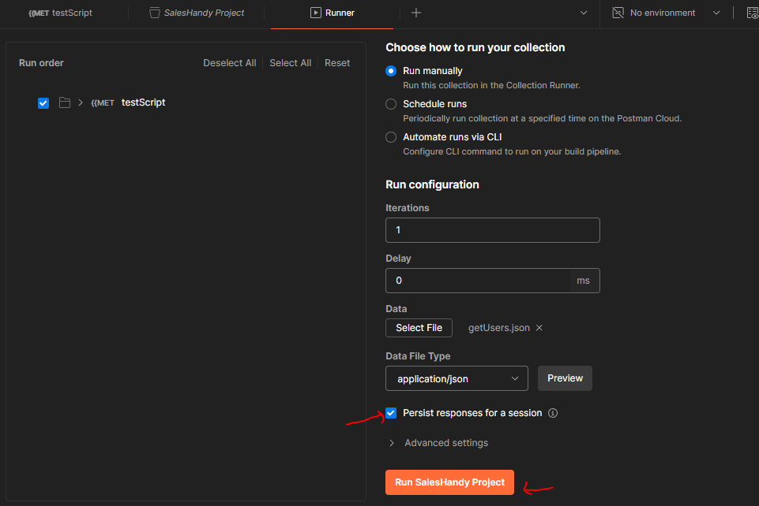

1. Once we have clicked on **Run SalesHandy Project**, then the result of all the tests will be displayed and then we can verify the status.

